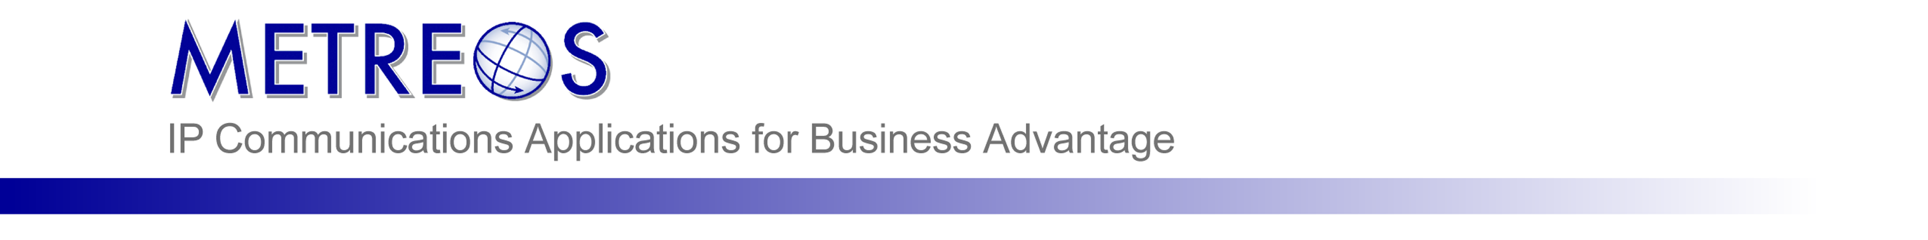

Metreos RemoteAgent

Administration Guide
Metreos Communications Environment 2.1.4

Information in this document is subject to change without notice.

Copyright © 2005 Metreos Corporation. All rights reserved. Metreos trademarks marked with ® or © herein are registered or protected trademarks of Metreos in the U.S. and foreign countries. All other trademarks in the document are the property of their respective owners.
Licensing Terms
Use of this Software is subject to license restrictions. Carefully read this license agreement before using the software.
This End User License Agreement (the “Agreement”) is a legal agreement between you, either individually or as an authorized representative of the company or organization acquiring the license, and Metreos Corporation (“Metreos”). USE OF SOFTWARE INDICATES YOUR COMPLETE AND UNCONDITIONAL ACCEPTANCE OF THE TERMS AND CONDITIONS SET FORTH IN THIS AGREEMENT. If you do not agree to these terms and conditions, promptly return or, if electronically received, certify destruction of the Software and all accompanying items within five days after receipt of Software and you will receive a full refund of the applicable license fees paid.
1. License Grant
a. The software programs you are installing, downloading, or have acquired with this Agreement, including any related equipment or hardware, documentation, updates, upgrades, modifications, revisions, copies and design data (“Software”) are copyrighted, trade secret and confidential information of Metreos and its licensors who maintain exclusive title to all Software and retain all rights not expressly granted by this Agreement. Metreos grants to you, subject to payment of appropriate license fees, a non-exclusive, non-transferable, internal-use only, term license to use the Software owned or distributed by Metreos in machine readable, object-code form on the computer hardware or at the site(s) for which an applicable license fee has been paid, as authorized by Metreos.
b. To the extent that you design applications that operate on the Metreos Communications Environment (the “MCE”), Metreos grants you a non-exclusive, non-transferable, internal-use only, term license to use the Software, including the MCE, for the purposes of operating such programs, subject to payment of appropriate license fees.
c. The license granted herein is contingent on your (or your organization’s) continued acceptance and subscription to the maintenance and support terms provided by Metreos. Termination by you or your organization of ongoing maintenance and support requirements terminates the license granted herein.
2. Restrictions and Intellectual Property Ownership
a. You may not (i) remove or modify any notice of Metreos’ proprietary rights, (ii) re-license, rent, lease, timeshare, or act as a service bureau or provide subscription services for the Software, (iii) use the Software to provide third-party training, except for training agents and contractors authorized under this Agreement; (iv) assign this Agreement or give the Software or an interest in the Software to another individual or entity; (v) cause or permit reverse engineering or decompilation of the Software; (vi) disclose results of any Software benchwork tests without Metreos’ prior written consent; or (vii) modify the Software or any portions thereof without Metreos’ prior written consent.
b. The Software, which is copyrighted, and any modifications, upgrades, or updates thereto, is the sole and exclusive property of Metreos and is a valuable asset and trade secret of Metreos. Metreos retains all ownership and intellectual property rights to the Software and to any modifications, upgrades, or updates thereto. Except for the rights granted in herein above, you shall have no right, title, or interest of any kind in or to the Software.
c. Metreos may audit your use of the Software. If Metreos gives you or your organization reasonable advance written notice, you agree to cooperate with the audit, and to provide reasonable assistance and access to information. You agree to immediately remit any underpaid license and technical support fees determined as the result of such audit.
3. Term and Termination.
a. This Agreement remains effective until expiration or termination. This Agreement will immediately terminate upon notice if you exceed the scope of the license granted or otherwise fail to comply with the provisions in sections 1 and 2 above. For any other material breach of the Agreement, Metreos may terminate this Agreement if you are in breach and fail to cure the breach within thirty (30) days of written notification. If Software is provided for a limited term use, this Agreement will automatically expire at the end of the authorized term.
b. Upon termination of this Agreement for any reason, you shall within ten (10) business days return to Metreos all Software Additionally, you agree to delete from any permanent machine storage (i.e., hard disk) previously loaded copies of the Software in all forms. Upon request of Metreos, you shall certify in writing that all copies of the Software and associated documentation have been destroyed or returned to Metreos. The indemnity and limitation of liability obligations hereunder, as well as your obligations with respect to confidential treatment of the Software and Metreos’ trade secrets, other intellectual property, and proprietary information, shall survive the termination of this Agreement.
4. Limited Warranty.
a. Metreos warrants that the Software will substantially operate as described in the applicable Software documentation for ninety (90) days after Metreos delivers it to you. THE WARRANTY HEREIN IS EXCLUSIVE AND IN LIEU OF ALL OTHER WARRANTIES, WHETHER EXPRESS OR IMPLIED, INCLUDING THE IMPLIED WARRANTIES OF MERCHANTABILITY AND FITNESS FOR A PARTICULAR PURPOSE. METREOS MAKES NO WARRANTY THAT ANY SOFTWARE WILL PERFORM ERROR-FREE OR UNINTERRUPTED, OR THAT ALL ERRORS THEREIN CAN OR WILL BE CORRECTED. METREOS FURTHER DISCLAIMS ANY IMPLIED WARRANTIES ARISING FROM COURSE OF PERFORMANCE, COURSE OF DEALING OR USAGE OF TRADE.
b. For any breach of the above warranty, Metreos’ entire liability and your exclusive remedy shall be, at Metreos’ option, either (1) refund of the fees paid upon return of the Software to Metreos, or (2) correction or replacement of the Software that does not meet this limited warranty, provided you have complied with the terms of this Agreement.
5. Indemnity
a. Metreos will defend and indemnify you against a claim that any Software, infringes a patent or copyright, provided that: (i) you notify Metreos in writing within thirty (30) days of the claim; (ii) Metreos has sole control of the defense and all related settlement negotiations; and (iii) you provide Metreos with the assistance, information, and authority reasonably necessary to perform the above; reasonable out-of-pocket expenses incurred by you in providing such assistance will be reimbursed by Metreos.
b. Metreos shall have no liability for any claim of infringement resulting from: (i) your use of a superseded or altered release of the Software if infringement would have been avoided by the use of a subsequent unaltered release of the Software which Metreos provides to you; or (ii) any information, design, specification, instruction, software, data, or material not furnished by Metreos or (iii) any combination of the Software with other hardware, software or processes that, but for the combination, the Software would not be infringing.
c. In the event that some or all of the Software is held or is believed by Metreos to infringe, Metreos shall have the option, at its expense: (i) to modify the Software to be non-infringing; or (ii) to obtain for you a license to continue using the Software. If it is not commercially feasible to perform either of the above options, then Metreos may require from you return of the infringing Software and all rights thereto. Upon return of the infringing Software to Metreos, you may terminate the Agreement with ten (10) days’ written notice and you shall be entitled to a pro-rata refund of the fees paid for the infringing Software. This subsection sets forth Metreos’ entire liability and exclusive remedy for infringement.
d. You will defend and indemnify Metreos and its licensors against any claim incurred by, borne by or asserted against Metreos or its licensors that relates to or results from (i) your use of the Software, (ii) any intentional or willful conduct or negligence by you or (iii) any breach of an applicable representation, covenant or warranty contained herein.
e. Should the party seeking indemnification (“Indemnitee”) reasonably determine that the party from whom indemnity is sought (“Indemnitor”) has failed to assume the defense of any claim referenced herein, Indemnitee shall have the right to assume such defense and have all expense and cost of the defense reimbursed by Indemnitor, including reasonable attorneys fees.
6. Confidentiality
The Software contains proprietary and confidential information of Metreos as well as trade secrets owned by Metreos. You agree to hold the Software in strict confidence and not to disclose the Software in any way except as expressly permitted hereunder. You agree to protect the Software at least to the same extent that you protect your similar confidential information, but in no event less than reasonable care. You further agree that you will not, directly or indirectly, copy the structure, sequence, or organization of the Software, nor will you copy any portion of the Software or related documentation to produce software programs that are substantially similar to the Software.
7. LIMITATION OF LIABILITY
EXCEPT WHERE THIS EXCLUSION OR RESTRICTION OF LIABILITY WOULD BE VOID OR INEFFECTIVE UNDER APPLICABLE LAW, IN NO EVENT WILL METREOS BE LIABLE FOR ANY INDIRECT, INCIDENTAL, SPECIAL, OR CONSEQUENTIAL DAMAGES, OR DAMAGES FOR LOSS OF PROFITS, REVENUE, DATA, OR USE, INCURRED BY YOU OR ANY THIRD PARTY, WHETHER IN AN ACTION IN CONTRACT OR TORT, EVEN IF METREOS OR ANY OTHER PERSON HAS BEEN ADVISED OF THE POSSIBILITY OF SUCH DAMAGESMETREOS’ LIABILITY FOR DAMAGES HEREUNDER SHALL IN NO EVENT EXCEED THE AMOUNT OF FEES PAID BY YOU FOR THE SOFTWARE OR SERVICE GIVING RISE TO THE CLAIM. IN THE CASE WHERE NO AMOUNT WAS PAID, METREOS SHALL HAVE NO LIABILITY FOR ANY DAMAGES WHATSOEVER.
8. Assignment; Jurisdiction.
This Agreement will be binding upon, and will inure to the benefit of, the permitted successors and assigns of each party hereto. You may not assign, delegate, transfer, or otherwise convey this Agreement, or any of its rights hereunder, to any entity without the prior written consent of Metreos, and any attempted assignment or delegation without such consent shall be void. This Agreement, and all matters arising out of or relating to this Agreement, shall be governed by the laws of the State of Texas, United States of America. Any legal action or proceeding relating to this Agreement shall be instituted in any state or federal court in Travis or Dallas County, Texas, United States of America. Metreos and you agree to submit to the jurisdiction of, and agree that venue is proper in, the aforesaid courts in any such legal action or proceeding.
9. Severability; Waiver
In the event any provision of this Agreement is held to be invalid or unenforceable, the remaining provisions of this Agreement will remain in full force. The waiver by either party of any default or breach of this Agreement shall not constitute a waiver of any other or subsequent default or breach. Except for actions for nonpayment or breach of either party’s intellectual property rights, no action, regardless of form, arising out of this Agreement may be brought by either party more than two years after the cause of action has accrued. The headings appearing in this Agreement are inserted for convenience only, and will not be used to define, limit or enlarge the scope of this Agreement or any of the obligations herein.
10. Restricted Rights Notice.
The Software is commercial in nature and developed solely at private expense. The Software is delivered as "Commercial Computer Software" as defined in DFARS 252.227-7014 (June 1995) or as a commercial item as defined in FAR 2.101(a) and as provided with only such rights as are provided in this Agreement, which is Metreos’ standard commercial license for the Software. Technical data is provided with limited rights only as provided in DFAR 252.227-7015 (Nov. 1995) or FAR 52.227-14 (June 1987), whichever is applicable.

TABLE OF CONTENTS

1. Purpose 1

2. Overview 1

2.1. RemoteAgent 1

2.2. Agent Script 1

2.3. Administrator Script 4

2.4. Procedure Overview 5

3. Step 1: Configure Cisco CallManager for the MCE 5

3.1. SCCP 7960 IP Phones for Receiving Calls from IPCC 5

3.2. SCCP 7960 IP Phones for Making Calls to Remote Agents 6

3.3. Adding an H.323 Gateway and Route Pattern 7

4. Step 2: Configuring IPCC for RemoteAgent 7

5. Step 3: Configure the Metreos Communications Environment 7

5.1. Adding a Media Server 8

5.2. Adding a SCCP Device Pool Group 9

5.3. Adding a CallManager Telephony Server 10

5.4. Defining Inbound and Outbound SCCP device pools 12

6. Step 4: Install the RemoteAgent Application 12

7. Step 5: Configure the RemoteAgent Application 12

8. Step 6: Edit the Default Partition 12

9. Step 7: Edit Trigger Parameters of the Agent Script 12

10. Step 8: Edit Trigger Parameters of the Administrator script 12

11. Step 9: Set Up RemoteAgent Users 12

12. Step 10: Set Up RemoteAgent Supervisors 12

13. Step 11: Set Up Other Partitions 12

- Purpose
This document provides step-by-step instructions on the configuration of RemoteAgent within the Metreos Communications Environment and Cisco CallManager.
In addition, conceptual information is provided to give the administrator an understanding of each step as it is explained.
- Overview
  - RemoteAgent
RemoteAgent is a Metreos application which can receive a call from IPCC, determine which call center agent the call is destined for, and then place another call to the agent’s Find Me number, bridging the two calls together. Because the agent can configure any number accessible by the CallManager involved in the call flow, agents are no longer bound to an IP phone when performing call center duties.
Supervisory features are also included in RemoteAgent. A supervisor can dial-in to the Administrator script, and choose individual extensions to monitor and optionally record.
The Metreos Communications Environment (MCE) is capable of leveraging a number of call control protocols, such as CTI, H.323, and SCCP.
  - Agent Script
Since the RemoteAgent Agent script runs in the context of the MCE, it can be configured to use CTI, H.323, or SCCP protocols to accept the inbound call, as well as to place the second call to the agent’s Find Me number.
Throughout this document it is assumed that the SCCP protocol is used as both the inbound and outbound protocol for the RemoteAgent Agent script.
  - SCCP is required as the inbound protocol because IPCC can only place calls to SCCP devices.
  - SCCP is recommended as the outbound protocol to incorporate with existing CDR analysis tools that rely on well-known IP phone extensions originating calls.
Configurations for the Agent script are located in three places—Cisco CallManager Administration, MCEAdmin, and AppSuiteAdmin.
Cisco CallManager
Component | Description
Range of SCCP devices | Range of SCCP devices for receiving the agent call
Range of SCCP devices | Range of SCCP devices for calling the agent’s Find Me number

MCEAdmin
Component | Description
CallManager Telephony Server | Whenever one leverages CCM-specific protocols, a CCM telephony server must be created
SCCP Device Pool | Correlates to range of SCCP devices used to receive agent calls.
SCCP Device Pool | Correlates to a range of devices used to call the agents Find Me numbers.
SCCP Device Pool Group | Used to contain the SCCP device pool receiving agent calls.
SCCP Device Pool Group | Used to contain the SCCP device pool calling agent Find Me numbers
Media Server | Used to bridge both call legs together
RemoteAgent | The RemoteAgent application contains the Agent script
Trigger Parameters | The partitioned Agent script should define every line extension associated with it as a To parameter

AppSuiteAdmin
Component | Description
User Profile | A user profile must be created for every RemoteAgent user
User Device | The user profile stores the line extension of the virtual SCCP phone allocated to the agent
Find Me number | The user profile stores all pre-defined and the active Find Me number

The call flow of this script is shown on the following page.

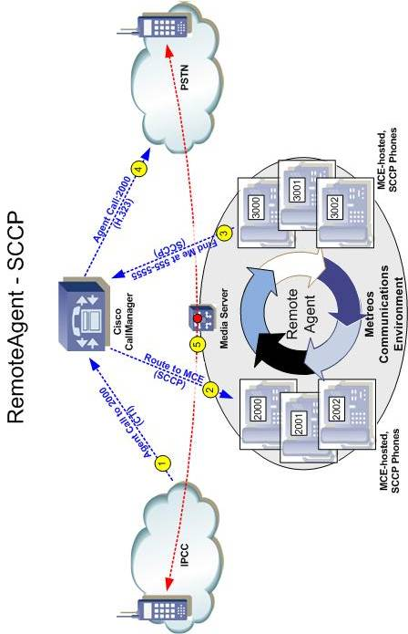
Figure 1: RemoteAgent using SCCP as the outbound call protocol
  - Administrator Script
As with the Agent script, the RemoteAgent Administrator script can be configured to use any protocol to enable dial-in access.
This document presents the case in which the H.323 protocol is used to enable dial-in access to the RemoteAgent Administrator script.
  - H.323 is recommended as the inbound protocol. CallManager should be configured such that calls are routed to the MCE as an H.323 gateway. CallManager places no constraints on the number of simultaneous calls that can be placed to an H.323 gateway, so access to the Administrator script is bound only by the performance characteristics of the MCE server(s).
Configuration of Administrator script are contained in three places—Cisco CallManager Administration, MCEAdmin, and AppSuiteAdmin.
Cisco CallManager
Component | Description
H.323 Gateway | The supervisor script is called in to, so the only concern is routing a call to the MCE; easily achieved by using an H.323 gateway and route pattern
Route Pattern | The H.323 gateway must have a route pattern associated with it to allow supervisors to dial in

MCEAdmin
Component | Description
Media Server | Used throughout the supervisor dial-in script
RemoteAgent | The RemoteAgent application requires the Administrator script
Trigger Parameters | The partitioned Administrator script should define a number from the route pattern as the To parameter

AppSuiteAdmin
Component | Description
User Profile | A user profile must be created for every Remote Agent supervisor
User Account/Pin | The user profile stores the dial-in credentials for the supervisor

  - Procedure Overview
You will complete the following tasks to set up RemoteAgent in the Metreos Communications Environment (MCE).
  - Configure Cisco CallManager for the Agent script.
  - Configure Cisco CallManager for the Administrator script.
  - Configure IPCC.
  - Configure the Metreos Communications Environment.
  - Install the RemoteAgent application.
  - Configure the RemoteAgent application.
  - Edit the default partition.
  - Edit trigger parameters of the RemoteAgent Agent script.
  - Edit trigger parameters of the RemoteAgent Administrator script.
  - Set up RemoteAgent users.
  - Set up RemoteAgent supervisors.
  - Set up other partitions.
- Step 1: Configure Cisco CallManager for the MCE
To configure the Cisco CallManager for the MCE, you must do the following:
  - Create a range of SCCP 7960 IP phones that will be used by the RemoteAgent default partition to accept calls from IPCC.
  - Create a range of SCCP 7960 IP phones that will be used by the RemoteAgent default partition to make calls to agents.
  - Create an H.323 gateway and route pattern to enable dial-in access for the Administrator script of RemoteAgent.
These tasks are described in the following subsections.
  - SCCP 7960 IP Phones for Receiving Calls from IPCC
A SCCP phone must be created in Cisco CallManager for every user that will use RemoteAgent. These phones comprise a range that will be used for strictly receiving calls from IPCC. These phones correspond to MCE-hosted IP phones that will be defined later in the MCE.
Generally, all configurations on these IP phones should be configured the same as IP phones already defined for use with IPCC, aside from Device Name.
The range of phones created here will be defined in the MCE later.
Guidelines
- All phones in the range must be SCCP 7960s.
- Device Name must be sequential for the range of IP phones.
- The first Device Name in the range must start at 000000 for the least significant 6 hexadecimal digits.
- All Device Names in the range must start with the same most significant 6 hexadecimal digits, known as the 6-Digit MAC Address Prefix within the MCE. The Device Names in the range should all be unique and not already in existence in CallManager.
- All other configuration of the devices should match dial plan, dialing rules, and other standard practices for your Cisco CallManager and IPCC deployment.
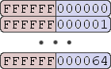
  - SCCP 7960 IP Phones for Making Calls to Remote Agents
Figure 2: Example Device Name Range for 100 Devices
A second SCCP phone must be created in Cisco CallManager for every user that will use RemoteAgent. These phones will be configured in a range that will be used strictly for making calls to Remote Agents. These phones correspond to MCE-hosted IP phones that will be defined for later in the MCE.
Generally, configurations for these phones should be the same as that for IP phones already defined for use with IPCC, with the exception of Device Name.
The range of phones created here will be defined in the MCE later.
Guidelines
- All phones in the range must be SCCP 7960s.
- Device Name must be sequential for the range of IP phones.
- The first Device Name in the range must start at 000000 for the least significant 6 hexadecimal digits.
- All Device Names in the range must start with the same most significant 6 hexadecimal digits, known as the 6-Digit MAC Address Prefix within the MCE.
- The Device Names in the range should all be unique and not already in existence in CallManager.
- The Calling Search Space of the phone should be such that it will route all conceivable Remote Agent Find Me numbers, as configured by agents on their Metreos account profile.
All other configuration of the devices should match dial plan, dialing rules, and other standard practices for your Cisco CallManager and IPCC deployment.
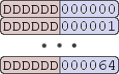
  - Adding an H.323 Gateway and Route Pattern
Figure 3: Example Device Name Range for 100 Devices
Create an H.323 gateway in CallManager.
Guidelines
- Device Name must correspond to the IP address of the MCE server.
- All other configuration of the gateway should match dial plan, dialing rules, and other standard practices for your Cisco CallManager and IPCC deployment.
Create a route pattern associated with the H.323 gateway.
Guidelines
- Partition should be such that supervisors can dial-in to the script from whatever phone device they would use to invoke the Administrator script.
- Description should contain the word Metreos, to help in quickly locating resources in CallManager allocated to Metreos applications.
- Gateway or Route List must be the H.323 gateway created earlier.
- Step 2: Configuring IPCC for RemoteAgent
The range of SCCP IP phones created for receiving calls from IPCC in Step 1: Configure Cisco CallManager for the MCE, should be configured as callable endpoints in IPCC.
- Step 3: Configure the Metreos Communications Environment
In Step 1: Configure Cisco CallManager for the MCE, we configured two ranges of SCCP IP phones.
You will use the Metreos Communications Environment console (mceadmin) to configure the Metreos Communications Environment. The steps involved are:
  - Adding a Metreos Media Server.
  - Adding a SCCP device pool group.
  - Adding a CallManager telephony server.
  - Defining inbound and outbound SCCP device pools.
  - Adding a Media Server
Complete the following steps to add a media server to the MCE configuration.
Procedure
- Go to http://<servername or IPaddress>/mceadmin.
- Select Media Servers.
- Click the Add a Media Server button. The following screen appears.
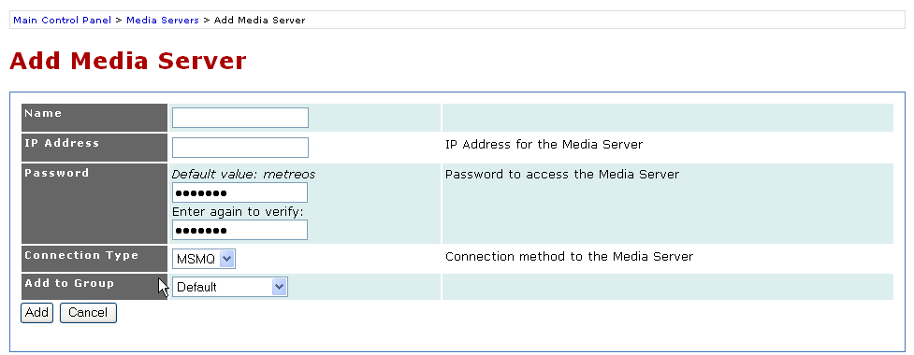
- Enter a descriptive name for the media server in the Name field, and the media server’s IP address in the IP Address field.
Figure 4: Adding a Media Server in the Metreos Management Console
- Enter the SFTP password for the media server in the Password field, and enter the same password again in the field below to confirm the password originally entered.
- Select a connection method to the media server in the Connection Type field.
- As an option, select a group from the Add to Group pull-down menu, or leave the field set as Default to place the media server into the default media group.
- Click the Add button to complete configuring the MCE.
- Repeat steps 2 through 5 to add additional media servers as needed.
  - Adding a SCCP Device Pool Group
For each device range created in Step 1, we will need to create one SCCP device pool group. As a rule, all device pools defined in the MCE must belong to a device pool group. Because one device pool will be used for making calls, and the other for receiving calls, it is necessary that we put each device pool into a unique group. Otherwise, a conflict could arise during the operation of RemoteAgent in which a device intended for receiving calls is unexpectedly making a call at that moment, or vice versa.
Procedure
- To create the group which will contain the inbound SCCP device pool (not yet created), go to http://<servername or IPaddress>/mceadmin.
- Select Telephony Servers.
- Under Call Route Groups, make sure SCCP Device Pool Group is present in the dropdown, as show in the following figure.
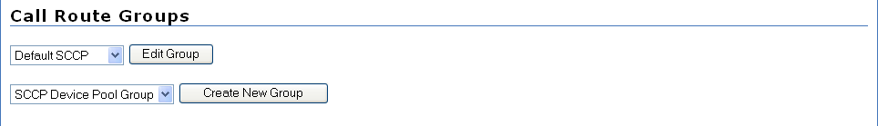
- Select Create New Group. The following screen appears.
Figure 5: SCCP Device Pool Group Selected under Call Route Groups
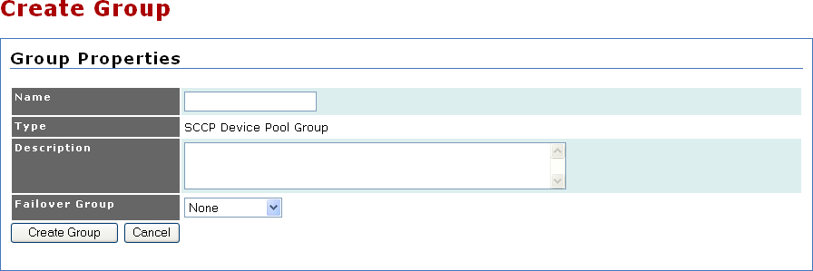
- Specify a name and description for this SCCP Device Pool Group and leave Failover Group as none. In either the name or description, it is suggested that the label reflect that this device pool group should only be used for inbound SCCP devices.
Figure 6: Adding a SCCP Device Pool Group
- Complete steps 1-4 for the outbound device pool group and be sure to label these devices for outbound use only.
  - Adding a CallManager Telephony Server
Complete the following steps to add a CallManager telephony server.
Procedure
- Go to http://<servername or IPaddress>/mceadmin.
- Select Telephony Servers.
- Under Add a Telephony Server, make sure that Call Manager is selected in the pull-down menu as shown in the following figure.
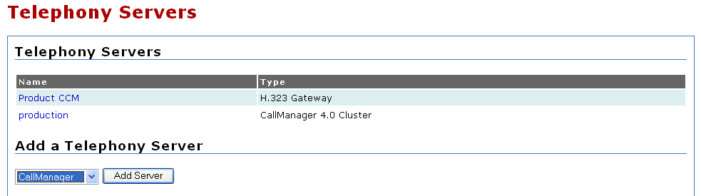
- Click the Add Server button. The following screen appears.
Figure 7: Call Manager Selected under Add a Telephony Server
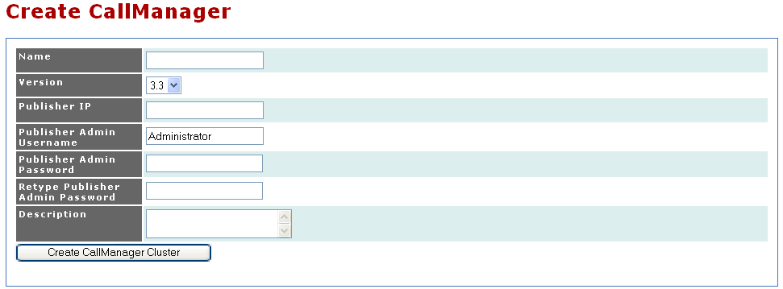
- Enter the CallManager name, publisher IP address, publisher IP username, publisher admin password (twice), and a short description.
Figure 8: Adding a CallManager Telephony Server in the Metreos Management Console
- Click the Create CallManager Cluster button. The following screen appears.
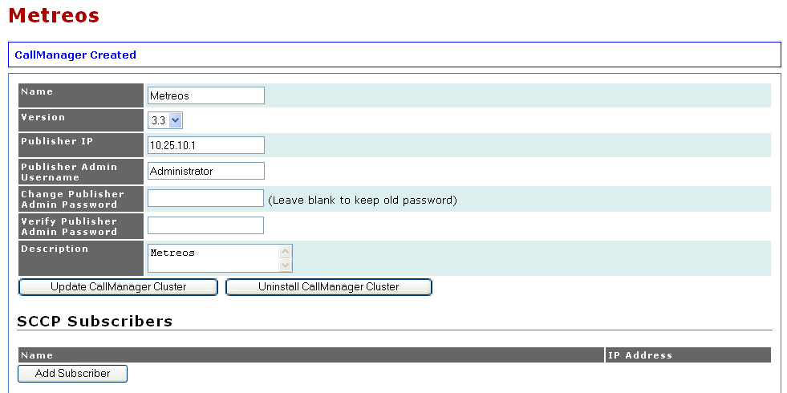
- Under SCCP Subscribers, click the Add Subscriber button as shown in the following figure. This should be done for each subscriber that is having MCE register devices to it.
Figure 9: CallManager Selected under Add a Telephony Server
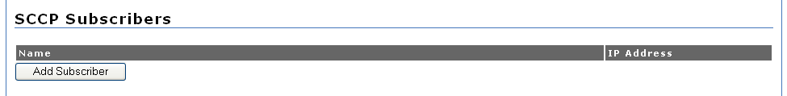
- Enter the name and IP address of the subscriber. This should be a CallManager node that is processing calls.
Figure 10: Adding Subscribers to CallManager Nodes
- Click the Add Subscriber button as shown in the following figure.
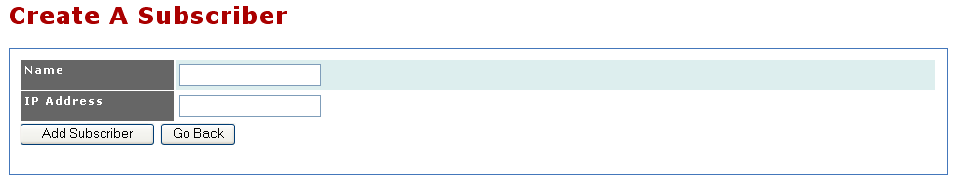
- After you enter each subscriber, click the Update CallManager Cluster button.
Figure 11: CallManager Subscribers Nodes
  - Defining Inbound and Outbound SCCP device pools
CallManager-specific capabilities in the Metreos Communications Environment can be enabled once a CallManager telephony server has been defined and SCCP Subscribers are defined for that CallManager cluster.
It is now possible to define SCCP device pools that correspond to the two device ranges made in Step 1: Configure Cisco CallManager for the MCE. Steps are shown for the inbound SCCP device pool.
Procedure
- Navigate to the CallManager telephony server configuration page, and find the Devices, as shown below.
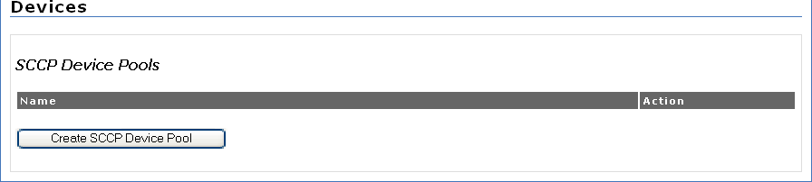
- After you have created a SCCP subscriber, the inbound SCCP device pool can be created. Under Devices, select the Create SCCP Device Pool button in the configuration page of the CallManager Cluster you created above. The following screen appears.
Figure 12: Navigating to Create SCCP Device Pool section
This must be done for each of the device pool ranges created in Step 1: Configure Cisco CallManager for the MCE.
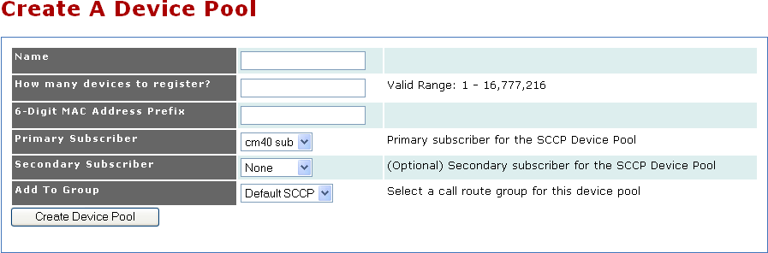
- On the Create A Device Pool page, enter the name of the pool. It is suggested, for clarity, the term inbound is present in the name you choose. Also, define the number of SCCP devices to register, the initial six hexadecimal characters to use for the device pool, the primary subscriber, the optional secondary subscriber, and choose which SCCP call route group in which to add the devices. These values should correspond exactly to the range of 7960 IP phones created in Step 1: Configure Cisco CallManager for the MCE.
Figure 13: Adding a SCCP Device Pool
- Repeat steps 1-3 to create the outbound SCCP device pool.
- Step 4: Install the RemoteAgent Application
Complete the following steps to install the RemoteAgent application.
Procedure
- Go to https://<servername or IPaddress>/ccmadmin
- Under Components, select Applications.
- Under Install an Application, click the Browse button as shown.
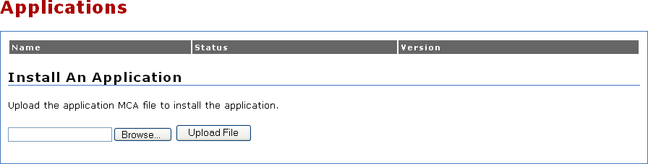
- Browse to the RemoteAgent.mca file from the Metreos directory
Figure 14: Installing the RemoteAgent Application
- Select the RemoteAgent.mca file.
- Click Open.
- Click the Upload File button.
- Step 5: Configure the RemoteAgent Application
When an application is first installed, all configuration items specific to the application are set to default values. You can change these default values at any time by following the steps outlined in this section. Note that all partitions will assume current default values, unless the configuration item was modified at the partition level.
Complete the following steps to modify the RemoteAgent application default configuration.
Procedure
- Go to http://<servername or IPaddress>/mceadmin.
- Select Applications.
- Select RemoteAgent. The following screen appears.
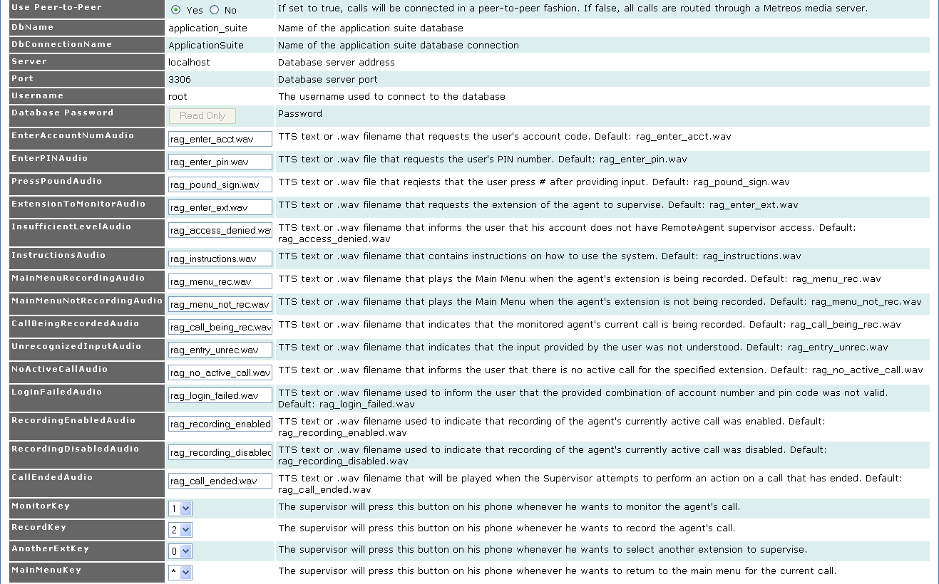
- Enter information into the fields shown above. Most of these fields are described in the table following. Fields with a value of *.wav on install are default media prompts used throughout RemoteAgent. Although it is generally recommended these fields should not be changed, the administrator can change these values, but only if text-to-speech capabilities have been provisioned.
Figure 15: Configuring RemoteAgent in mceadmin
- Click the Update button.
Field | Description
Use Peer-to-Peer | Should always be No.
MonitorKey | The supervisor uses this field to indicate that he or she wishes to monitor an agent’s call.
RecordKey | The supervisor uses this field to indicate that he or she wishes to record an agent’s call.
AnotherExtKey | The supervisor uses this field to indicate that he or she wishes to monitor a new extension.
MainMenuKey | The supervisor uses this field to indicate that he or she wishes to return to the main menu.
- Step 6: Edit the Default Partition
Figure 16: RemoteAgent Parameters
Complete the following steps to edit the default partition.
Procedure
- Go to http://<servername or IPaddress>/mceadmin.
- Under Components, select Applications.
- Select the RemoteAgent application and then proceed to Edit the Default Partition. The following screen appears.
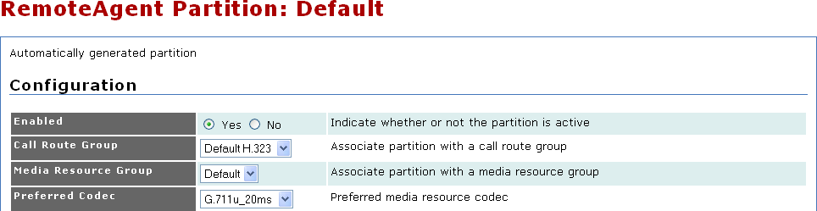
- Modify the RemoteAgent application configuration to meet your specific site requirements. For information on configuration parameters, refer to Table 1 on page 12
Figure 17: Editing the Default Partition
- For Call Route Group, ensure that an outbound SCCP Device Pool Group, created earlier, is chosen.
- Step 7: Edit Trigger Parameters of the Agent Script
The MCE matches incoming call control events with its list of trigger parameters to determine when to launch an instance of the RemoteAgent Agent script. Complete the following steps to define the trigger parameter for the RemoteAgent Agent script.
Procedure
- Go to http://<servername or IPaddress>/mceadmin.
- Select Applications.
- Select the RemoteAgent application, and then proceed to Edit the Default partition. The following screen appears.
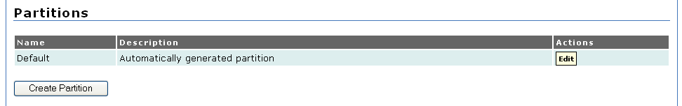
- Under Scripts, click the Edit Trigger Parameters button for the Agent script as shown following.
Figure 18: Editing the Default Partition
- Enter the value to for Parameter Name, and a line extension of the first device in the MCE-hosted, inbound SCCP device pool.
- Click the Add Parameter button as shown in the following figure.
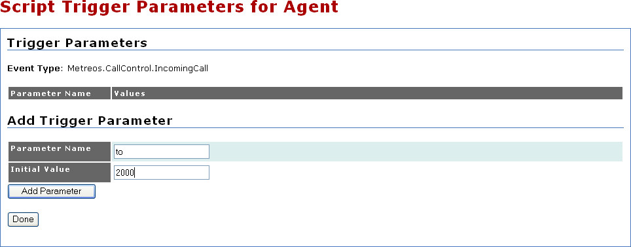
- For every device in the inbound SCCP device pool, enter a new line number in the empty text box next to the Add Value button, and click Add Value.
Figure 19: Creating To Parameter and a 1st value for Agent Script
- Click the Update Parameter Values button. A message appears indicating that the parameter values have been updated as shown in the following screen.
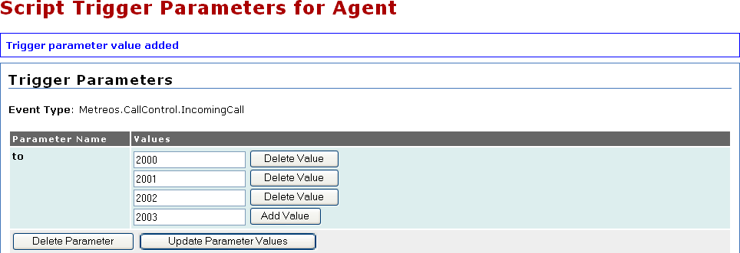
- Step 8: Edit Trigger Parameters of the Administrator script
Figure 20: Adding Additional Trigger Parameters to Agent Script
The MCE matches incoming call control events with its list of trigger parameters to determine when to launch an instance of the RemoteAgent Administrator script. Complete the following steps to define the trigger parameter for the RemoteAgent Administrator script.
Procedure
- Go to http://<servername or IPaddress>/mceadmin.
- Select Applications.
- Select the RemoteAgent application, and then proceed to Edit the Default partition. The following screen appears.
- Under Scripts, click the Edit Trigger Parameters button for the Administrator script as shown following.
Figure 21: Editing the Default Partition
- Enter the value to for Parameter Name. For the Initial Value field, enter the value of the route pattern created in Step 1: Configure Cisco CallManager for the Metreos Communications Environment.
- Click the Add Parameter button as shown in the following figure.
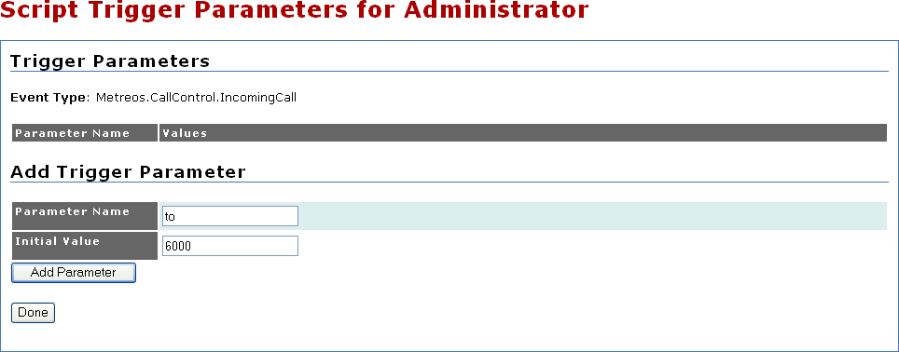
- Step 9: Set Up RemoteAgent Users
Figure 22: Creating To Parameter to match route pattern for Administrator script
Complete the following steps to create a user and associate a device from the inbound SCCP device pool with the user’s account.
Procedure
- Go to http://<servername or IPaddress>/appsuiteadmin.
- Select Account Management.
- Click the Create User button. Enter account information on the screen as shown following.
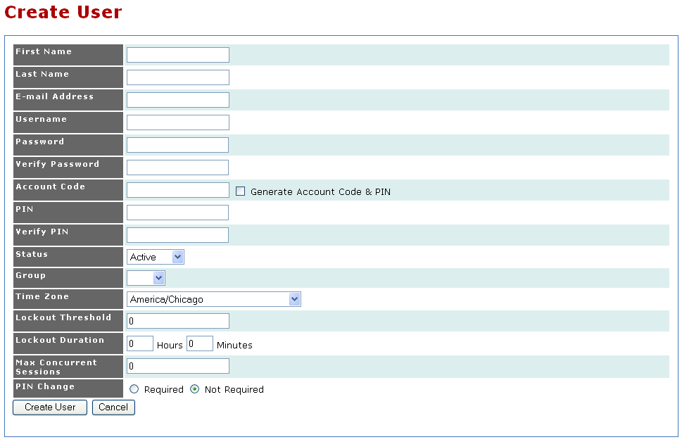
- Click the Create User button.
Figure 23: Adding a New User in Appsuiteadmin
- Scroll down the screen. Under Devices, click the Add Device button as shown in following screen.
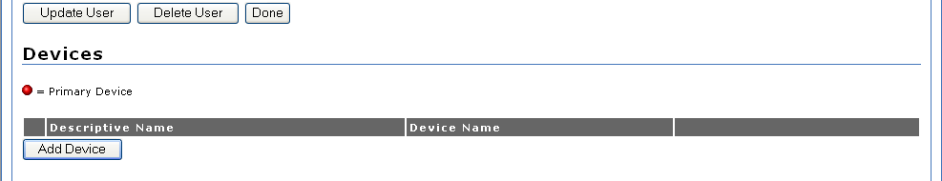
- Enter a friendly name and the device name of a SCCP phone from the inbound SCCP device pool. A SCCP device from the inbound device pool can only be associated with one user.
Figure 24: Adding a Device
- Click the Create Device button to add the device.
- After creating the device, add a line number to represent the actual line number on the SCCP device as configured in Cisco CallManager.
- Select the Enable Remote Agent for this User button.
- For the Remote Agent Device Field, choose the device made in step 7.
- Select Update.
The account is now ready. Users can log into their account via Appsuiteadmin, configure Find Me numbers, and mark the Find Me number as the number to use for RemoteAgent.
- Step 10: Set Up RemoteAgent Supervisors
Complete the following steps to create a supervisor. Creating a supervisor requires fewer steps than creating an agent because a supervisor account has no associated device—only credentials to be used when using the dial-in Administrator script.
Procedure
- Go to http://<servername or IPaddress>/appsuiteadmin.
- Select Account Management.
- Click the Create User button. Enter the account information on the following screen
- Take note when defining the Account Code and Pin. The supervisor will need these credentials when dialing into the Administrator script.
Figure 25: Adding a New User in Appsuiteadmin
- Click the Create User button.
- Select the Enable Remote Agent for this User button.
- Choose Supervisor from the User Level dropdown.
- Select Update.
- The account is now ready.
- Step 11: Set Up Other Partitions
Whenever an application such as RemoteAgent is installed, the Default partition is created automatically and initialized with the default configuration parameters defined in the application installer file.
However, any number of partitions can be created for a given application. While there are a number of possible situations in which an administrator might want to create additional partitions, the most frequent reason is to cause a single application to leverage specific, unique media resources and/or telephony resources based on specific triggering circumstances. For instance, if RemoteAgent end-users were located on multiple CallManager clusters, it would then be necessary to create new inbound and outbound device pools and groups as was done in Step 1: Configure Cisco CallManager for the Metreos Communications Environment, Step 2: Configure IPCC, and Step 3: Configure the Metreos Communications Environment.
Each partition will be associated with a specific Call Route Group and Media Resource Group. Also, any configuration items unique to an application, such as the MonitorKey for RemoteAgent, can be modified on a per-partition basis.
With the ability to configure unique Call Route Groups and Media Resource Groups, it is possible to define exactly which media servers are used by specific application partitions. It is also possible to define, for each partition, which CallManager cluster is used when making calls. This is done by specifying a Call Route Group corresponding to a particular outbound SCCP Device Pool Group.
Once you have a partition defined, it is then the final responsibility of the administrator to define under which conditions each partitioned script is triggered.
The following steps should be taken whenever a new partition is needed. Other steps, such as defining new CallManager telephony servers and SCCP device pools for that CallManager are assumed already done.
Procedure
- Go to http://<servername or IPaddress>/mceadmin.
- Under Components, select Applications.
- Select the RemoteAgent application.
- Under Partitions, Select Create Partition.
- Name and enable the new partition.
- Choose a Call Route Group appropriate for this partition. A call route group is used by RemoteAgent only when making outbound calls. In contrast, the protocol of the inbound call is determined by a combination of CallManager configuration and triggering parameters on the partitioned scripts.
- Choose a Media Resource Group appropriate for this partition. If one MCE server is coupled with multiple media server resource groups, the primary consideration should be which media server group is closest in proximity to IP endpoints.
- Modify any RemoteAgent-specific configuration items as needed.
- Select Create Partition.
- Under Scripts, select Edit Trigger Parameters for the Agent script.
- As with the Default partition, enter a to trigger parameter values for every line number of every SCCP device in the inbound SCCP device pool used for this partition.

